Progress Report
2025/04/14 Karter Wong
Progress
- Got rid of the vertical corners of my test shape
テストシェイプの垂直の角を取り除きました
  - Changed the features, the dimensions are the same as my previous test shape
機能を変更しましたが、寸法は以前のテスト形状と同じです
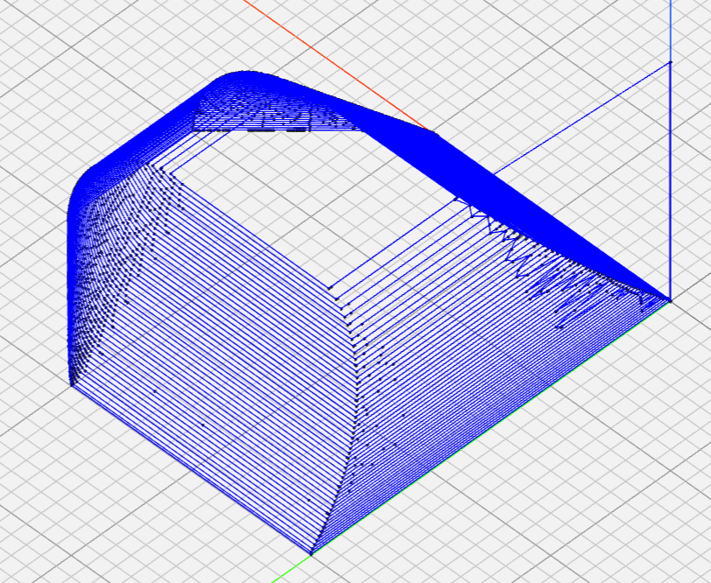
Figure 1: G-Code figure of the new test shape, view #1

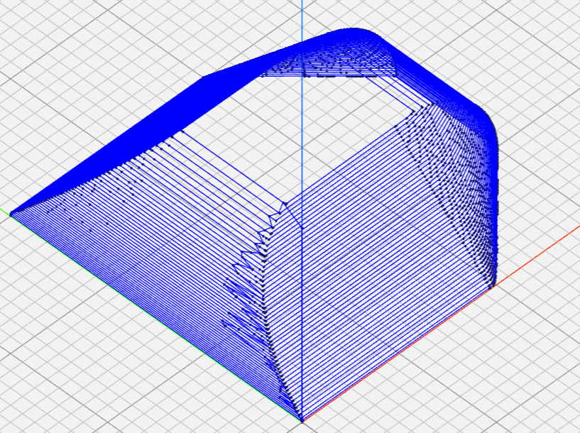
Figure 2: G-Code figure of the new test shape, view #2
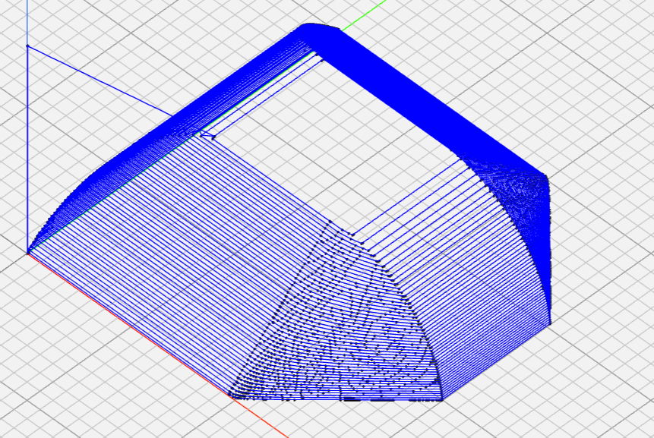
Figure 3: G-Code figure of the new test shape, view #3

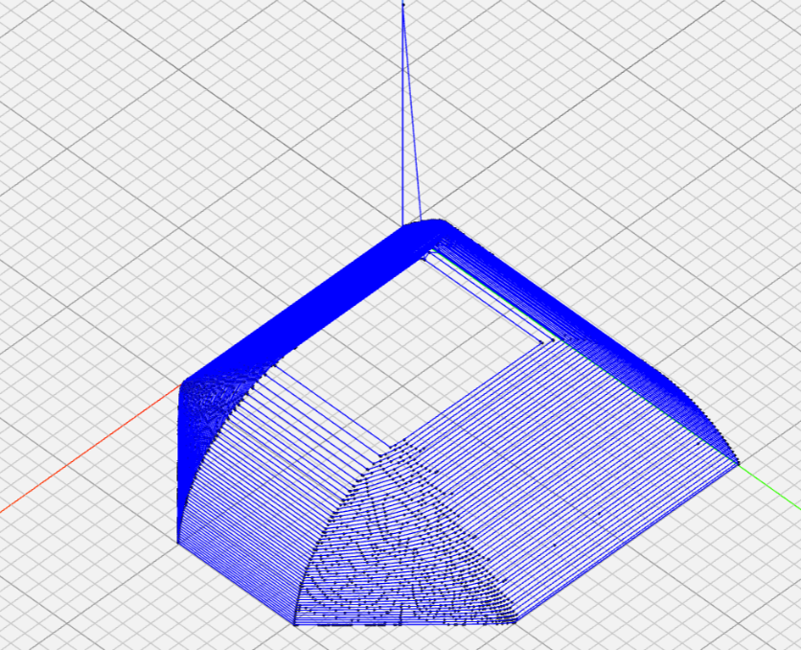
Figure 4: G-Code figure of the new test shape, view #4
- Did some reading on how to prevent springback
スプリングバックを防ぐ方法についていくつか読んだ
  - Optimum Process Parameters for Springback Reduction of Single Point Incrementally Formed Polycarbonate William L. Edwards, Tyler J. Grimm, Ihab Ragai* and John T. Roth
  - Although the material that was used was not CFRTP some of the findings might be applicable (heat treating the material after the incremental forming process, heating of the material through the forming process)
使用された材料はCFRTPではありませんでしたが、いくつかの発見は適用できる可能性があります（増分成形プロセス後の材料の熱処理、成形プロセス中の材料の加熱）
Plan
- Talk with Professor Tanaka about testing with CFRTP
CFRTPを用いた試験について田中教授と話し合う
- Do more research on ways to reduce the springback of the material
材料のスプリングバックを減らす方法についてさらに研究する
- Look at machining parameters
- Establish a timeline for graduation thesis
- Write a draft of the first two pages of my thesis

